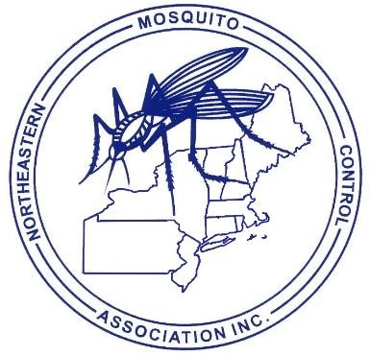
CALL FOR PAPERS – 2022

NORTHEASTERN MOSQUITO CONTROL ASSOCIATION www.nmca.org Cape Codder Resort & Spa
Hyannis, Massachusetts DECEMBER 5-7, 2022

TITLE:

AUTHOR(S):

AFFILIATION(S):

MAILING ADDRESS:

CITY/TOWN:

ZIP:

FAX:

STATE:

PHONE:

E-MAIL ADDRESS:

PRESENTER:

APPROXIMATE TIME NEEDED (Please try to limit talks to 20 minutes or less this year):

NOTE: For consideration for inclusion in this year’s program a comprehensive abstract is required. Presentations may not be scheduled on the Program without prior receipt of an abstract. Abstracts should be detailed enough to provide a complete overview of the presentation. Please e-mail abstracts in advance to editor@nmca.org.

We will try to accommodate requests to speak on certain dates, but we will not be able to accommodate everyone if everyone requests a certain day. Please only request a date if you absolutely cannot present on all or most of the other dates. Conversely, if you cannot present on a certain day, please let us know and we can almost certainly make sure to fit you in on another day.

The Program Committee asks that speakers try to limit their visual aids to PowerPoint® Presentations

Manuscripts for the Proceedings are encouraged to be submitted at the Annual Meeting. The final submission date for manuscripts is 60 days after the meeting or we will be using your abstract for submission.

SUBMIT PAPER TITLES BY November 25, 2022 TO:
CHUCK LUBELCZYK, NMCA PROGRAM CHAIR
MAINEHEALTH INSTITUTE FOR RESEARCH, VECTOR-BORNE DISEASE LABORATORY
81 RESEARCH DRIVE SCARBOROUGH, ME
PHONE (C): (207) 651-0385 PHONE (W): (207) 396-8246 E-MAIL: charles.lubelczyk@maine.edu

PLEASE E-MAIL ALL ABSTRACTS & ANY PRESENTATIONS UNDER 5MB IN SIZE PRIOR TO THE MEETING TO EITHER CHUCK LUBELCZYK OR NATE BOONISAR (editor@nmca.org)

