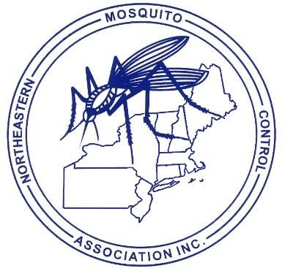**CALL FOR PAPERS – 2025**

***NORTHEASTERN MOSQUITO CONTROL ASSOCIATION***

[www.nmca.org](http://www.nmca.org/)

Margaritaville Resort

Hyannis, MA

DECEMBER 8-10, 2025

**TITLE:**

**AUTHOR(S):**

**AFFILIATION(S):**

**MAILING ADDRESS:**

**ZIP:**

**CITY/TOWN:**

**STATE:**

**PHONE:**  ­­­______________________ **FAX:**

**E-MAIL ADDRESS:**

**PRESENTER:**

**DESCRIPTION OF PRESENTATION:** Please attach to form. The description of talk will be published in the proceeding as the abstract if no abstract or manuscript is submitted. Please e-mail abstracts and/or manuscripts to [editor@nmca.org](mailto:editor@nmca.org). The final submission date is 60 days after the meeting. Manuscripts for the proceedings are encouraged to be submitted at the Annual Meeting.

**APPROXIMATE TIME NEEDED** (15-20 minutes preferred):

*We will try to accommodate requests to speak on certain dates, but we will not be able to accommodate everyone if everyone requests a certain day.*

Please limit visual aids to PowerPoint® Presentations.

SUBMIT PAPER TITLES BY November 1, 2025 TO:

program@nmca.org

John Shepard, NMCA Program Committee Chair

The CT Agricultural Experiment Station

123 Huntington St.

New Haven, CT 06511

PHONE (W): (203) 974-8517

Please email all abstracts and presentations under 5MB prior to the meeting to Nate Boonisar (editor@nmca.org)